Groovy Step

Objective

This step is used to execute any Custom external groovy code without having the main method.

Apache Groovy is an Object-oriented programming language used for Java platform. This dynamic language has many features which are similar to Python, Ruby, Smalltalk, and Pero. It can be used as a scripting language for the Java platform.

UI

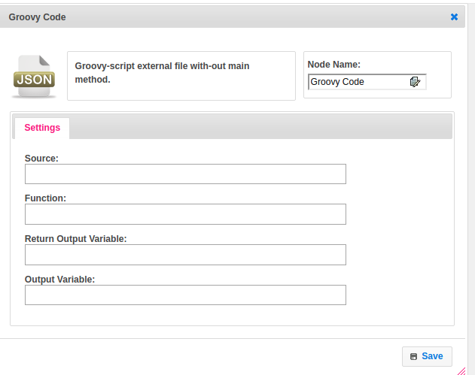

## Attributes

|  |  |
| --- | --- |
| **Attributes** | **Description** |
| **1. Source** | Provide the script name. |
| **2. Function** | Provide a function name. |
| **3. Return Output Variable** | Pass the dynamic params |
| **4. Output Variable** | Used to store the response of the request. |
| **5. Return Output Variable** | Give boolean values. |

## Executor Description:

Create the Binding class object, provided by Groovy API.Set map,lib_path,code-step and function name to this object.If function-name equals main then create an object for GroovyScriptEngine class by using GroovyScriptEngine one arg constructor, pass the URL(path of the file) as an argument to the constructor and call the run method of GroovyScriptEngine class by passing path and binding object as parameters.Else create an object of GroovyScriptEngine by passing lib path. Call getDeclaredMethod by passing function name and params.

## Resource:

To get more information, please find the following link.

<https://www.guru99.com/groovy-tutorial.html>